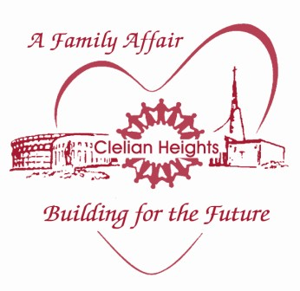
Clelian Heights School for Exceptional Children
All Gifts will be recognized in our Annual Report which includes gifts from July 1 until June 30 of each year.

Please print this form and mail to:
Clelian Heights, Inc. Mission Advancement Office 135 Clelian Heights School Greensburg, PA 15601-6665

Enclosed is my gift for Clelian Heights:

□ $1,000.00 □ $500.00 □ $250.00 □ $100.00 □ $75.00 □ $50.00 □ $25.00 □ Other NAME: ADDRESS:

CITY:
STATE:
ZIP:

PHONE:

EMAIL:

PAYMENT TYPE: □ MasterCard □ VISA □ Discover □ Check (Payable to Clelian Heights) Check #:

Card No.:

Expiration Date:

Cardholder’s Signature:

TOTAL CHARGE AMOUNT: $

Donor Recognition & Giving Levels:
$25,000+ - The Mother Clelia Founders Club
$10,000—$24,999 - The Clelian Directors Club
$ 5,000—$ 9,999 - The Clelian Leaders Club
$ 3,000—$ 4,999 - The Clelian Partners Club
$ 1,000—$ 2,999 - The Clelian Guardians Club
$ 500—$ 999 - The Clelian Sponsors Club
$ 250—$ 499 - The Clelian Supporters Club
$ 100—$ 249 - The Clelian Friends Club Under $99 - The Clelian Donors Club
- This is an anonymous gift, please do not publish.

Please use my gift for: (select one)
- Project Fund
- Endowment Fund
- Operational Fund
- Specified for:

Please make my gift :

In Honor of (Living or Deceased): Name:

In Memory of (Chapel Memorial for Deceased): Name:

Please send notice of this gift to:
Name:

Address:

Thank You!!!

City:
State: ZIP:

Enclosed is my Matching Gift form from my company.

Questions? Contact the Mission Advancement Office at 724-837-8120 ext. 123

